**Confused about DFS traversal of graph on Final Exam Problem 6A**

[gojun077](https://www.edx.org/courses/MITx/6.00x/2012_Fall/discussion/forum/users/267644) 2 days ago

I have attached an image illustrating the path I took through the graph for DFS. The yellow highlighted nodes represent the correct DFS path through the graph. 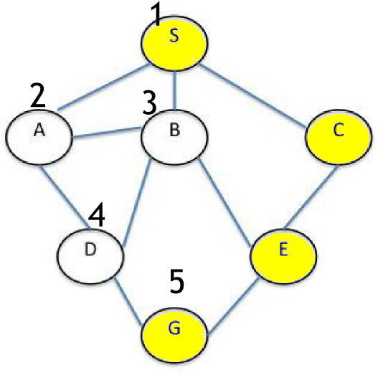

My logic in choosing the incorrect path S-A-B-D-G is as follows:

1) Push S onto the stack (stack: S), visit S and mark as visited. (adjacent, unvisited nodes A, B, C)

2) The next node connected to S in alphabetical order is 'A', so push it onto the stack (stack: A, S), visit it and mark it as visited. (adjacent unvisited nodes B, D)

3) The next node connected to A in alphabetical order is 'B', so push it onto the stack (stack: B, A, S), visit it and mark it as visited. (adj. unvisited nodes D, E)

4) The next node connected to B in alphabetical order is 'D', so push it onto the stack (stack: D, B, A, S), visit it and mark it as visited. (adj. unvisited node G)

5) The next node connected to D is 'G', so push it onto the stack (stack:G, D, B, A, S), visit it and mark it as visited. DONE

PATH: S-A-B-D-G

If I had instead went to the nodes in opposite alphabetical order, however, I would have gotten the correct path *S-C-E-G*. I followed an algorithm for DFS illustrated in the following YouTube video:

[DFS & BFS walkthrough](http://www.youtube.com/watch?v=zLZhSSXAwxI)

Could anyone point out flaws in my thinking?

1. [0](javascript:void(0)) [Justagirl](https://www.edx.org/courses/MITx/6.00x/2012_Fall/discussion/forum/users/35575)

a day ago

To follow through the code exactly then say what it does...

Top of Form



Bottom of Form

1. [4](javascript:void(0)) [xor](https://www.edx.org/courses/MITx/6.00x/2012_Fall/discussion/forum/users/470712)

2 days ago

I had the same problem.   
<https://www.edx.org/courses/MITx/6.00x/2012_Fall/discussion/forum/i4x-MITx-6_00x-course-2012_Fall/threads/50f54cb94372cc2b0000003a>

* + Thanks for the link! I should've read the provided code more carefully instead of assuming I understood DFS!

–posted 2 days ago by [gojun077](https://www.edx.org/courses/MITx/6.00x/2012_Fall/discussion/forum/users/267644)

* + aww snap! I made the same mistake of not actually going through the code thoroughly.

–posted 2 days ago by [mahela007](https://www.edx.org/courses/MITx/6.00x/2012_Fall/discussion/forum/users/483508)

* + Don't worry, I did the exact same thing. I said to myself, 'Oh I know this stuff, DFS and BFS, a piece of cake', and immediately proceeded to apply my understanding, not even bothering to read that code. Next time I will make sure I test the code before forming an opinion. ;)

–posted 2 days ago by [pmj](https://www.edx.org/courses/MITx/6.00x/2012_Fall/discussion/forum/users/4463)

Top of Form



Bottom of Form

1. [0](javascript:void(0)) [bwCA](https://www.edx.org/courses/MITx/6.00x/2012_Fall/discussion/forum/users/568610)

2 days ago

the intent was to walk through the code that was given - which forced you to visit the SC path first.

Top of Form



Bottom of Form

1. [6](javascript:void(0)) [Leep](https://www.edx.org/courses/MITx/6.00x/2012_Fall/discussion/forum/users/253306)

2 days ago

The children, in alphabetical order, are pushed to the beginning of the stack in turn. So SA gets pushed first (stack: SA), then SB (stack: SB, SA), then SC (stack: SC, SB, SA). Then they get popped off from the beginning; thus SC gets processed before SB and SA.

In other words, even though the children are in alphabetical order, because of the way they're pushed onto the stack (Last-In / First-Out, or "LIFO"), they get processed in reverse order.

Top of Form



Bottom of Form

1. [0](javascript:void(0)) [ahumahum](https://www.edx.org/courses/MITx/6.00x/2012_Fall/discussion/forum/users/252174)

2 days ago

I got into exact the same error... I will never forgive myself for that ;-).

Top of Form



Bottom of Form

1. [2](javascript:void(0)) [jcarreiro](https://www.edx.org/courses/MITx/6.00x/2012_Fall/discussion/forum/users/1698)

2 days ago

I made the same mistake.

Remember, DFS uses a stack, and the nodes get pushed onto it *in alphabetical order*. :)

Top of Form



Bottom of Form

1. [0](javascript:void(0)) [Peter_F19](https://www.edx.org/courses/MITx/6.00x/2012_Fall/discussion/forum/users/432646)

2 days ago

And I have made...-( But it's very good that we here explain what is the correct answer.

Top of Form



Bottom of Form

Top of Form

**Post a response:**

Bottom of Form